Lecture 1 – Advanced Signal processing
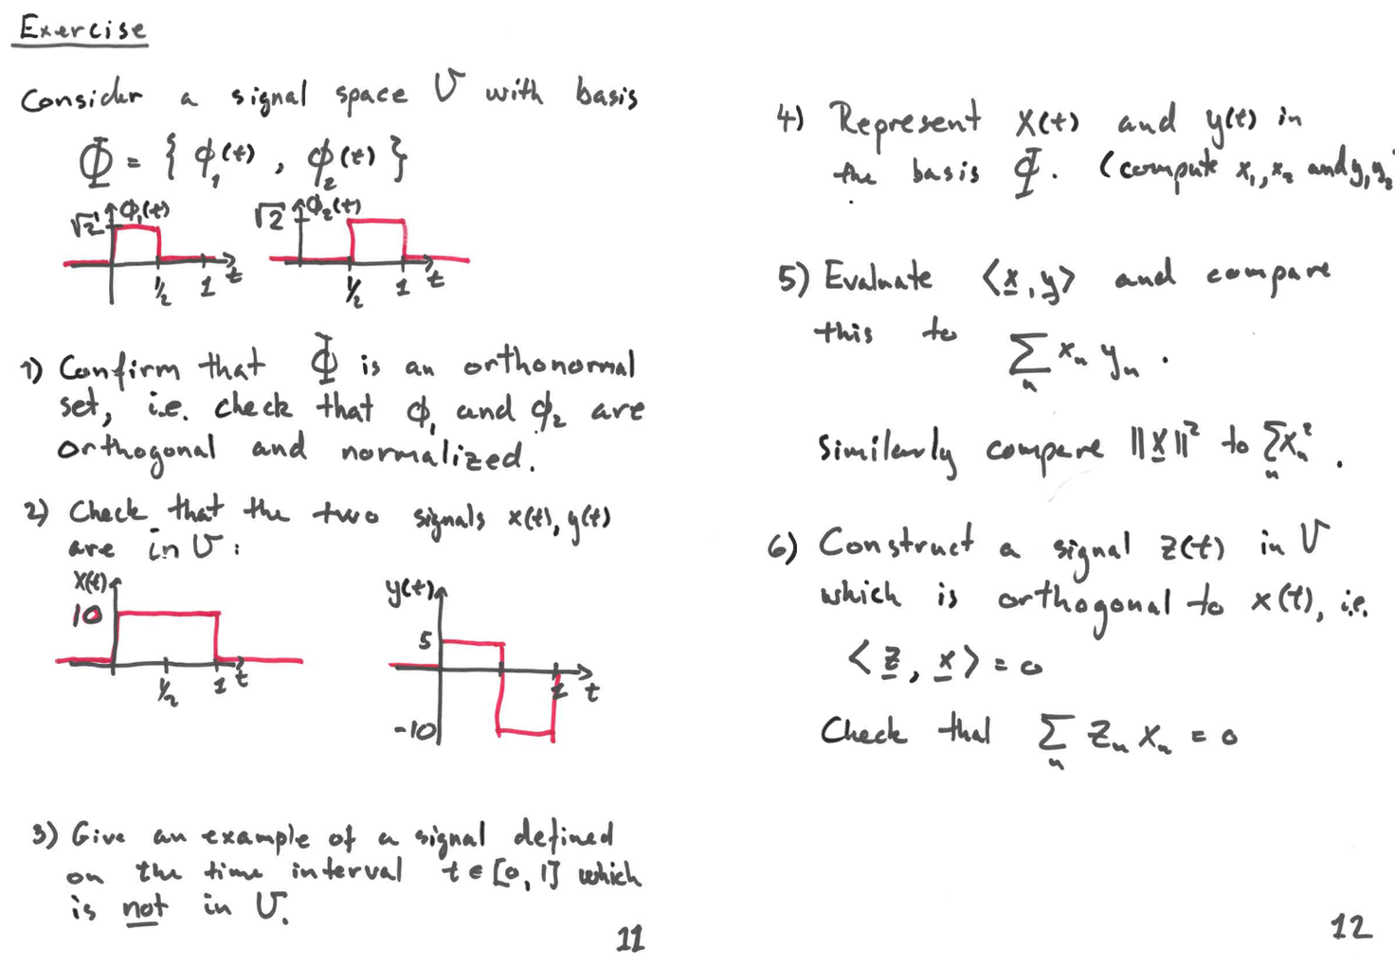

Given Information:
The signal space V has a basis set $(Φ=\{φ_{1}\left(t\right),φ_{2}\left(t\right)\})$ with the following basis functions:
- $φ_{1}\left(t\right)=\sqrt{2}$ for $0≤t<\frac{T}{2}$ and 0 otherwise.
- $φ_{2}\left(t\right)=\sqrt{2}$ for $\frac{T}{2}≤t≤T$, and 0 otherwise.

1. Confirm that $Φ$ is an orthonormal set
We need to check that $φ_{1}\left(t\right)$ and $φ_{2}\left(t\right)$ are orthonormal, i.e., they are orthogonal and normalized.

Orthogonality:
The inner product $\left\langle φ_{1},φ_{2}\right\rangle$ is defined as:
$$\left\langle φ_{1},φ_{2}\right\rangle =\int_{0}^{T}{φ_{1}\left(t\right)φ_{2}\left(t\right)} dt$$
From the definition of $φ_{1}\left(t\right)$ and $φ_{2}\left(t\right)$:
- $φ_{1}\left(t\right)$ is nonzero only for $0≤t<\frac{T}{2}$
- $φ_{2}\left(t\right)$ is nonzero only for $\frac{T}{2}≤t≤T$

Since the functions are nonzero over disjoint intervals, their inner product is 0:
$$\left\langle φ_{1},φ_{2}\right\rangle =0$$
Thus, $φ_{1}\left(t\right)$ and $φ_{2}\left(t\right)$ are orthogonal.

Normalization:
We now check that each function is normalized, i.e., $\left\langle φ_{1},φ_{1}\right\rangle =1$and $\left\langle φ_{2},φ_{2}\right\rangle =1$
- For $φ_{1}\left(t\right)$:
$$\left\langle φ_{1},φ_{1}\right\rangle =\int_{0}^{T}{φ_{1}{\left(t\right)}^{2}} dt=\int_{0}^{T/2}{{\left(\sqrt{2}\right)}^{2}} dt=\int_{0}^{T/2}{2} dt=2×\frac{T}{2}=T$$
However, we are looking for normalization. Thus, we divide $φ_{1}\left(t\right)$ by \(\sqrt{T}\), which is already considered in its original form of $\sqrt{2}$.

The same applies for $φ_{2}\left(t\right)$, so:

$$\left\langle φ_{2},φ_{2}\right\rangle =T$$

After normalization by the factor of $\sqrt{T}$, we confirm that both functions are normalized.

Thus, $Φ$ is an orthonormal set.

2. Check that the two signals x(t) and y(t) are in V
To check if x(t) and x(t) are in V, we need to see if they can be expressed as linear combinations of $φ_{1}\left(t\right)$ and $φ_{2}\left(t\right)$.

Signal x(t):
$$x\left(t\right)=\left\{\begin{aligned}10, &0 ≤t < \frac{T}{2} \\ 0, &\frac{T}{2} ≤t ≤ T\end{aligned}\right.$$

This signal is nonzero over the same interval as $φ_{1}\left(t\right)$, so we can express x(t) as a scalar multiple of $φ_{1}\left(t\right)$:

$$x\left(t\right)=x_{1}φ_{1}\left(t\right)$$

To find $x_{1}$, we use the inner product:

$$x_{1}=\left\langle x\left(t\right),φ_{1}\left(t\right)\right\rangle =\int_{0}^{T}{x\left(t\right)φ_{1}\left(t\right)} dt=\int_{0}^{T/2}{10}×\sqrt{2} dt=10\sqrt{2}×\frac{T}{2}=10T$$

Thus, $x\left(t\right)=10Tφ_{1}\left(t\right).$

Signal y(t):

$$y\left(t\right)=\left\{\begin{aligned}5, &0 ≤t < \frac{T}{2} \\ -10, &\frac{T}{2} ≤t ≤ T\end{aligned}\right.$$

We express y(t) as a linear combination of $φ_{1}\left(t\right)$ and $φ_{2}\left(t\right)$:

$$y\left(t\right)=y_{1}φ_{1}\left(t\right)+y_{2}φ_{2}\left(t\right)$$

- For $y_{1}$:

$$y_{1}=\left\langle y\left(t\right),φ_{1}\left(t\right)\right\rangle =\int_{0}^{T/2}{5}×\sqrt{2} dt=5\sqrt{2}×\frac{T}{2}=5T$$

- For $y_{2}$:

$$y_{2}=\left\langle y\left(t\right),φ_{2}\left(t\right)\right\rangle =\int_{T/2}^{T}{\left(-10\right)}×\sqrt{2} dt=-10\sqrt{2}×\frac{T}{2}=-10T$$

Thus, $y\left(t\right)=5Tφ_{1}\left(t\right)-10Tφ_{2}\left(t\right).$

Since both signals can be expressed as linear combinations of $φ_{1}\left(t\right)$ and $φ_{2}\left(t\right)$, they belong to V.

3. Example of a signal not in V
An example of a signal that is not in V would be a signal that cannot be represented as a combination of $φ_{1}\left(t\right)$ and $φ_{2}\left(t\right)$. For instance, consider:

$$z\left(t\right)=\sin\left(\frac{πt}{T}\right)$$

This signal is continuous and non-piecewise constant, so it cannot be expressed as a linear combination of $φ_{1}\left(t\right)$ and $φ_{2}\left(t\right)$, which are both piecewise constant functions. Thus, this signal does not belong to V.

4. Represent $x\left(t\right)$ and $y\left(t\right)$ in the basis $Φ$
From the previous calculations:
- $x\left(t\right)=10Tφ_{1}\left(t\right)$
- $y\left(t\right)=5Tφ_{1}\left(t\right)-10Tφ_{2}\left(t\right)$

Thus, in the basis $Φ$ we have:
- $x_{1}=10T, x_{2}=0$
- $y_{1}=5T, { y}_{2}=-10T$

5. Evaluate $\left\langle x,y\right\rangle$ and compare to $\sum_{n}{x_{n}y_{n}}$
We now compute the inner product $\left\langle x,y\right\rangle$:

$$\left\langle x,y\right\rangle =\int_{0}^{T}{x\left(t\right)y\left(t\right)} dt=10T×5T=50T^{2}$$

Now, compare this with the sum of products of coefficients:

$$\sum_{n}{x_{n}y_{n}}=\left(10T\right)\left(5T\right)+\left(0\right)\left(-10T\right)=50T^{2}$$

Both are equal, so the computation holds.

Similarly, for the norm:

$$|x|^{2}=\left\langle x,x\right\rangle ={\left(10T\right)}^{2}=100T^{2}$$

$$\sum_{n}{x_{n}^{2}}={\left(10T\right)}^{2}+0^{2}=100T^{2}$$

Again, both values match.

6. Construct a signal $z\left(t\right)$ in V orthogonal to $x\left(t\right)$
We want to find z(t) such that $\left\langle z,x\right\rangle =0$. Let:

$$z\left(t\right)=z_{1}φ_{1}\left(t\right)+z_{2}φ_{2}\left(t\right)$$

We need $\left\langle z,x\right\rangle =0$, or equivalently:

$$z_{1}\left\langle φ_{1},φ_{1}\right\rangle +z_{2}\left\langle φ_{2},φ_{1}\right\rangle =0$$

Since $\left\langle φ_{2},φ_{1}\right\rangle =0$, this simplifies to:

$$z_{1}\left\langle φ_{1},φ_{1}\right\rangle =z_{1}T=0$$

Thus, $z_{1}=0$

Now choose any $z_{2}$, say $z_{2}=1$, then:

$$z\left(t\right)=φ_{2}\left(t\right)$$

Finally, check that $\sum_{n}{z_{n}x_{n}}=0$

$$z_{1}x_{1}+z_{2}x_{2}=0×10T+1×0=0$$

Thus, the condition is satisfied.

Summary of Results:
1. $Φ$ is an orthonormal set.
2. x(t) and y(t) are in V.
3. An example of a signal not in V is $z\left(t\right)=\sin\left(\frac{πt}{T}\right).$
4. In the basis $Φ$:
- $x\left(t\right)=10Tφ_{1}\left(t\right)$
- $y\left(t\right)=5Tφ_{1}\left(t\right)-10Tφ_{2}\left(t\right)$
5. $\left\langle x,y\right\rangle =\sum_{n}{x_{n}y_{n}}=50T^{2},$ and $|x|^{2}=\sum_{n}{x_{n}^{2}}=100T^{2}.$
6. A signal $z\left(t\right)=φ_{2}\left(t\right)$ is orthogonal to x(t).

